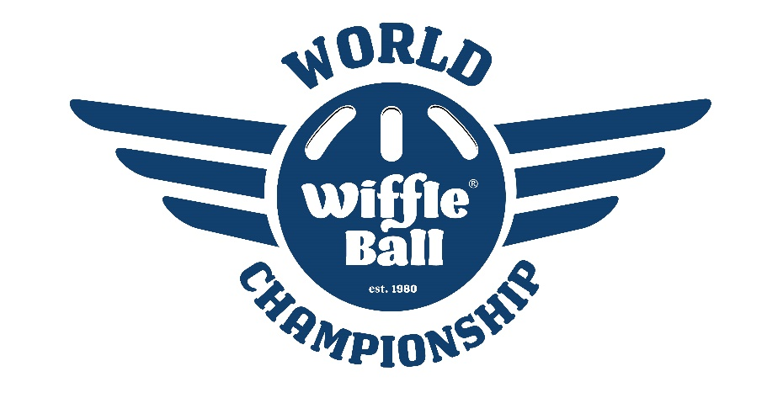

2023 World Champions – Clutch Players

Saturday, July 15, 2023 – Pool Play Results

Newt Division  Loweriders*  New Carlisle Newts**  Knights**  LaGrange Wiffle Academy**  Dingers  Clutch Division  Clutch Players*  TB Billy Goats**  Dirty Stallis**  Midlo Marauaders (HL)  Vipers  Ripped Division  Club Ripped*  Ohio Knuckleheads**  Lynn St. Leps**  Iowa Wifflehawks**  Red Ball Jets  Funky Division  Funky Plastic Offspring*  Bloomfield Bombers**  PP4L**  Palos Elite  Sparks | Chicago, IL  New Carlisle, IN  New Carlisle, IN  Miami Beach, FL  Tinley Park, IL  South Bend, IN  Mishawaka, IN  Wauwatosa, WI  Midlothian, IL  Chicago, IL  Munster, IN  Mentor, OH  New Carlisle, IN  Sioux City, IA  Roseau, MN  Mishawaka, IN  Chicago, IL  Union Mills, IN  Palos Heights, IL  Frankfort, IL | 4-0  2-2  2-2  2-2  0-4  4-0  3-1  2-2  1-3  0-4  3-1  3-1  2-2  2-2  0-4  4-0  3-1  2-2  1-3  0-4 |  | Builders Division  Granger Panthers*  Lombard Lightning**  GSGL Godfathers**  Bloodline  Green Giants  Homies Division  Wiffle Dees*  GP Black**  Hadler’s Chili**  The Next Step  Dirtier Stallis  Warrior Division  The M.O.B.*  Maple City Magic**  Milwaukee Beers**  Monon Yankers***  Thirsty Aunts  Homies Division  Balco Boys*  Warsaw Whitecats**  The Cousins**  Premium Dudes  Killas (DNP) | Granger, IN  Lombard, IL  Niles, MI  Chicago, IL  Oak Forest, IL  South Bend, IN  Granger, IN  Arl. Heights, IL  Muncie, IN  West Allis, WI  South Bend, IN  La Porte, IN  Frankfort, IL  Olathe, KS  Chicago, IL  Mishawaka, IN  Warsaw, IN  Wheaton, IL  Lisle, IL | 4-0  3-1  2-2  1-3  0-4  4-0  3-1  2-2  1-3  0-4  4-0  3-1  2-2  1-3  0-4  4-0  3-1  2-2  1-3
*Division Winner
**Sunday Qualifier
***1-3 Play-In Winner

Sunday, July 16, 2023 – Single Elimination Tournament
27 Teams

First Round
Lynn St. Leps def GSGL Godfathers
Lombard Lightning def The Cousins
Club Ripped def PP4L
Bloomfield Bombers def Dirty Stallis
New Carlisle Newts def Ohio Knuckleheads
Knights def GP Black
Maple City Magic def LaGrange Wiffleball Academy
Balco Boys def Monon Yankers
Hadler’s Heartwarming Chili def Loweriders
Warsaw Whitecats def Iowa Wifflehawks
Milwaukee Beers def Twin Branch Billy Goats

Sweet 16
Wiffle Dees def Lynn St. Leps
Lombard Lightning def Club Ripped
The M.O.B. def Bloomfield Bombers
Clutch Players def New Carlisle Newts
Knights def Funky Plastic Offspring
Balco Boys def Maple City Magic
Hadler’s Heartwarming Chili def Warsaw Whitecats
Granger Panthers def Milwaukee Beers

Elite 8
Wiffle Dees def Lombard Lightning
Clutch Players def The M.O.B.
Knights def Balco Boys
Granger Panthers def Hadler’s Heartwarming Chili
Final 4
Clutch Players def Wiffle Dees
Granger Panthers def Knights

World Championship

Clutch Players def Granger Panthers

