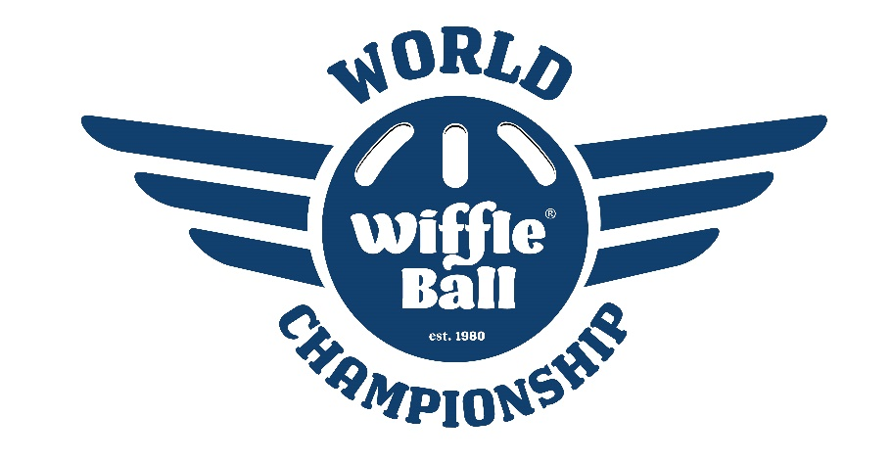

2022 World Champions – New Carlisle Newts

Saturday, July 16, 2022 – Pool Play Results

Newt Division  New Carlisle Newts*  Lombard Lightning**  Dirty Stallis**  Royals  Flight  Balco Division  Bloomfield Bombers*  Balco Boys**  LWA Water Buffaloes**  The Next Step***  Sparks  Ripped Division  The M.O.B.*  The Cousins**  Club Ripped**  Glitter Balls  Big Stick Diplomacy (DNP)  Builders Division  Granger Panthers*  Warsaw Whitecats**  Wifflehouse**  262 Beer Chuggers  Balls Johnson | New Carlisle, IN  Lombard, IL  Wauwatosa, WI  Plainfield, IL  Bridgeview, IL  Palatine, IL  Mishawaka, IN  La Grange, IL  Indianapolis, IN  Frankfort, IL  Elkhart, IN  Wheaton, IL  Munster, IN  Chicago, IL  Granger, IN  Warsaw, IN  Hammond, IN  Racine, WI  Michiana Shores, IN | 4-0  3-1  2-2  1-3  0-4  4-0  3-1  2-2  1-3  0-4  4-0  3-1  2-2  1-3  4-0  3-1  2-2  1-3  0-4 |  | Warrior Division  GP Black*  Cult West Warriors**  Midlothian Marauders**  Premium Dudes!  Breaking Balls (DNP)  Clutch Division  Wiffle Dees*  Clutch Players**  Milwaukee Beers**  Sand Trap Dingers  Iowa Wifflehawks  Funky Division  Funky Plastic Offspring*  TB Billy Goats**  Monon Yankers**  Earn It Everyday  Milwaukee Beers 2  Homies Division  Ohio Knuckleheads*  Green Stem Godfathers**  Loweriders**  Front Yard Bombers  Red Ball Jets | Granger, IN  South Bend, IN  Midlothian, IL  Lisle, IL  “Cityless”, IN  South Bend, IN  Frankfort, IL  Evansville, WI  Sioux City, IA  Mishawaka, IN  Mishawaka, IN  Olathe, KS  Lombard, IL  Oak Forest, IL  Mentor, OH  Niles, MI  Chicago, IL  Lombard, IL  Mishawaka, IN | 4-0  3-1  2-2  1-3  4-0  3-1  2-2  1-3  0-4  4-0  3-1  2-2  1-3  0-4  4-0  3-1  2-2  1-3  0-4
*Division Winner
**Sunday Qualifier
***1-3 Play-In Winner

Sunday, July 17, 2022 – Single Elimination Tournament
25 Teams

First Round
Loweriders def The Cousins 4-0
Cult West Warriors def Milwaukee Beers 7-2
GP Black def The Next Step 1-0
Club Ripped def Lombard Lightning 2-1
Twin Branch Billy Goats def LWA Water Buffaloes 3-2
Balco Boys def Midlothian Marauders 7-3
Clutch Players def Dirty Stallis 4-3
Warsaw Whitecats def Monon Yankers 9-6
Wifflehouse def Green Stem Godfathers 8-5

Sweet 16
Funky Plastic Offspring def Loweriders 5-1
Cult West Warriors def GP Black 7-1
Ohio Knuckleheads def Club Ripped 4-3
New Carlisle Newts def Twin Branch Billy Goats 5-3
Bloomfield Bombers def Balco Boys 3-0
Granger Panthers def Clutch Players 6-3
Wiffle Dees def Warsaw Whitecats 4-2
The M.O.B. def Wifflehouse 10-3

Elite 8
Cult West Warriors def Funky Plastic Offspring 5-3
New Carlisle Newts def Ohio Knuckleheads 10-2
Granger Panthers def Bloomfield Bombers 9-1
Wiffle Dees def The M.O.B. 5-1
Final 4
New Carlisle Newts def Cult West Warriors 7-1
Wiffle Dees def Granger Panthers 7-4

World Championship

New Carlisle Newts 9
Wiffle Dees 7

