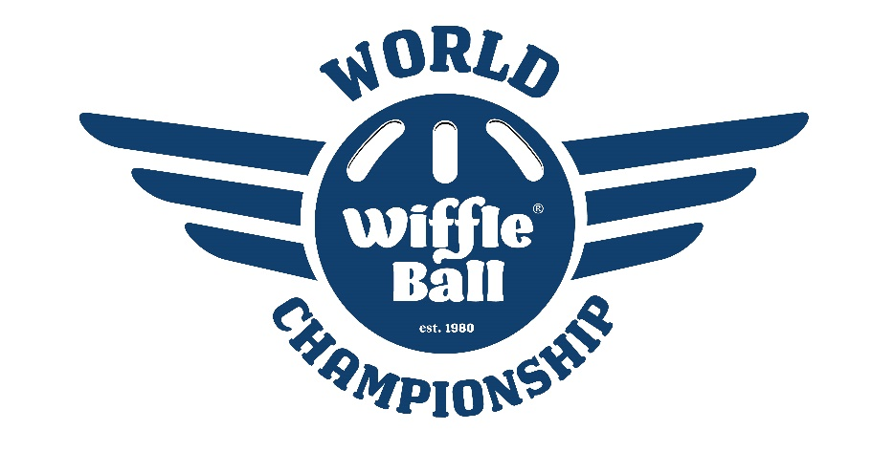

2021 World Champions – New Carlisle Newts

Saturday, August 14, 2021 – Pool Play Results

Builders Division  New Carlisle Newts*  Great Lakes Godfathers**  Chet Steadman**  The Cousins***  Dancing Lobsters  Babys Division  Maple City Magic*  GP Black**  Milwaukee Beers**  Pink Pandas  Premium Dudes!  Clutch Division  Clutch Players*  Read About It**  LWA Water Buffaloes**  Pitches Gone Wild  BrightDogs  Balco Division  Lombard Lightning*  Balco Boys**  Elite 260**  Glitter Balls  Big Stick Diplomacy  Warrior Division  Cult West Warriors*  Chippewas**  The Biscuits**  Vipers  Steal Curtain | New Carlisle, IN  Niles, MI  Chicago, IL  Wheaton, IL  Indianapolis, IN  La Porte, IN  Granger, IN  Frankfort, IL  Union Mills, IN  Lisle, IL  South Bend, IN  Queens, NY  La Grange, IL  Oak Forest, IL  Joliet, IL  Lombard, IL  Mishawaka, IN  Bluffton, IN  Chicago, IL  Brookfield, IL  South Bend, IN  Lake Superior, MI  Chicago, IL  Chicago, IL  Pittsburgh, PA | 4-0  3-1  2-2  1-3  0-4  4-0  3-1  2-2  1-3  0-4  4-0  3-1  2-2  1-3  0-4  4-0  3-1  2-2  1-3  0-4  4-0  3-1  2-2  1-3  0-4 |  | Homies Division  Wiffle Dees*  TB Billy Goats**  The Rescues**  Milwaukee Beers 2  Little Cubs Field (DNP)  Ripped Division  Club Ripped*  Bloomfield Bombers**  Old Style**  Tigers Blood  Lynn St. Leps (DNP)  Funky Division  Funky Plastic Offspring*  Iowa Wifflehawks**  Loweriders**  Click Clack Patty Whack  Belly Itchers  Dud’s Division  Granger Panthers*  Ohio Knuckleheads**  Dirty Stallis**  The Washed Up Wifflers  Back Yard Wiffs  Sure Things Division  The M.O.B.*  Warsaw Whitecats**  Monon Yankers**  Midlothian Marauders**  The Babushkas | South Bend, IN  Mishawaka, IN  Addison, IL  Oak Forest, IL  Munster, IN  Palatine, IL  Crown Point, IN  Vernon Hills, IL  Mishawaka, IN  Sioux City, IA  Chicago, IL  Wheaton, IL  Holland, MI  Granger, IN  Mentor, OH  Wauwatosa, WI  Countryside, IL  Burbank, IL  Elkhart, IN  Warsaw, IN  Olathe, KS  Midlothian, IL  Morton Grove, IL | 4-0  3-1  2-2  1-3  4-0  3-1  2-2  1-3  4-0  2-2  2-2  1-3  1-3  4-0  3-1  2-2  1-3  0-4  4-0  2-2  2-2  2-2  0-4
*Division Winner
**Sunday Qualifier
***1-3 Play-In Winner

Sunday, August 15, 2021 – Single Elimination Tournament
32 Teams

First Round
Wiffle Dees def The Cousins
Ohio Knuckleheads def Godfathers
Milwaukee Beers def Lombard Lightning
Club Ripped def Midlothian Marauders
Maple City Magic def Chet Steadman
Bloomfield Bombers def Monon Yankers
LWA Water Buffaloes def Read About It
Cult West Warriors def Elite 260
New Carlisle Newts def The Biscuits
Twin Branch Billy Goats def GP Black
The M.O.B. def Loweriders
Clutch Players def Iowa Wifflehawks
Granger Panthers def Old Style
Balco Boys def Dirty Stallis
Chippewas def Warsaw Whitecats
Funky Plastic Offspring def The Rescues

Sweet 16
Ohio Knuckleheads def Wiffle Dees
Club Ripped def Milwaukee Beers
Maple City Magic def Bloomfield Bombers
Cult West Warriors def LWA Water Buffaloes
New Carlisle Newts def Twin Branch Billy Goats
The M.O.B. def Clutch Players
Granger Panthers def Balco Boys
Chippewas def Funky Plastic Offspring

Elite 8
Ohio Knuckleheads def Club Ripped
Cult West Warriors def Maple City Magic
New Carlisle Newts def The M.O.B.
Granger Panthers def Chippewas
Final 4
Ohio Knuckleheads def Cult West Warriors
New Carlisle Newts def Granger Panthers

World Championship
New Carlisle Newts 12 Ohio Knuckleheads 4

